

**ABOUT ME**

NGUYỄN THÁI KỲ ANH (S3914486)

horizontal line

**Quick Introduction**

My name is Nguyen Thai Ky Anh (S3914486), I am 19 Years old. My ambition is to become a computer engineer after graduating from university. I want to have a secure future and contribute to technical advancements. I am fascinated by computer science and the discovery of new technologies. Furthermore, sports are an important part of my life, and I often decide to swim after a hard day at the computer since it provides me a cool and refreshing vibe.

**IT Interest**

I quite like machine learning and artificial intelligence. it may be the trend in the future. In addition, while studying online, I also researched and learned more about web programming.I am curious and interested when I can create my own blog in the future. About my experience in IT I can write a website and create useful tools in python.

**Some My Personal Test**

[**https://www.16personalities.com/profiles/0b4380041e847**](https://www.16personalities.com/profiles/0b4380041e847)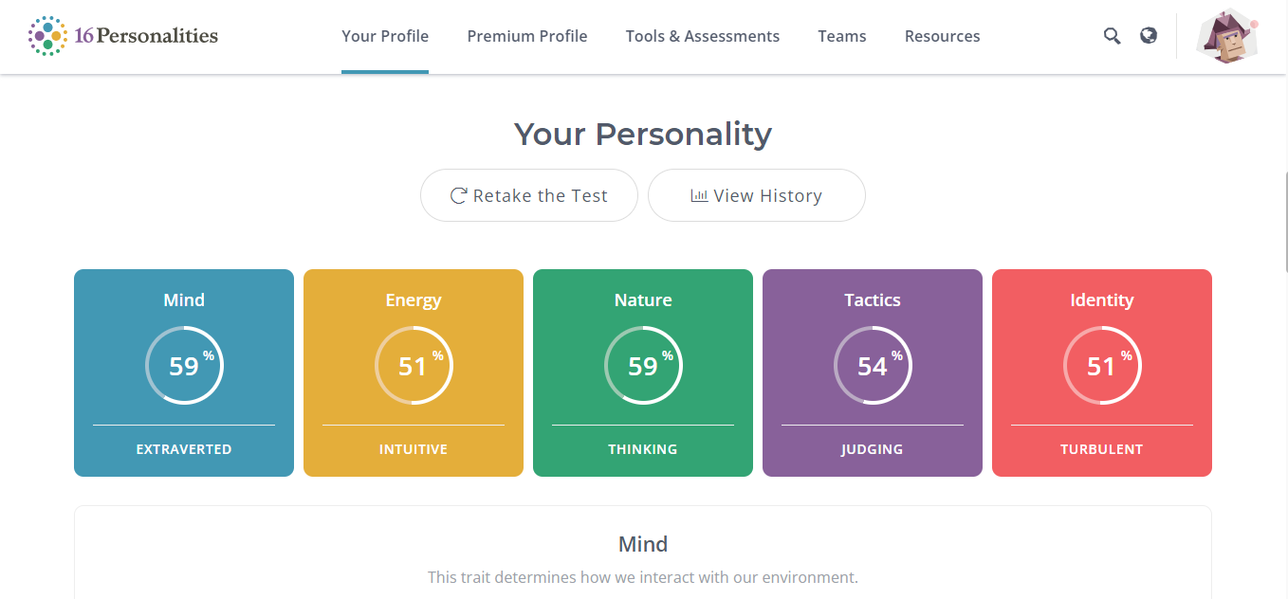

<http://www.educationplanner.org/students/self-assessments/learning-styles-quiz.shtml?event=results&A=8&V=6&T=6>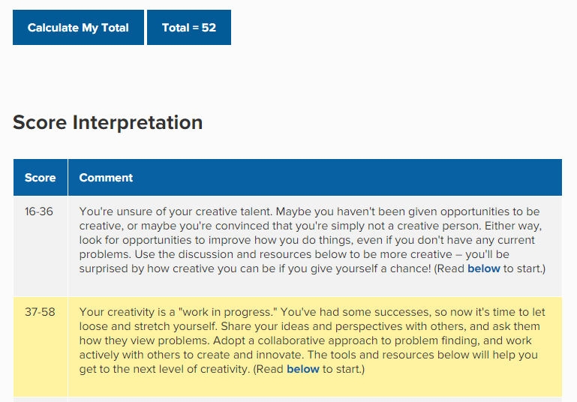

<https://www.mindtools.com/pages/article/creativity-quiz.htm#Explanation>